每日时事专刊

In Iran, Cheetah Sightings Offer Rare Spots of Hope Amid War (Translated to Chinese)
来源: NYT World 发布时间: 2026-04-28 04:01\n
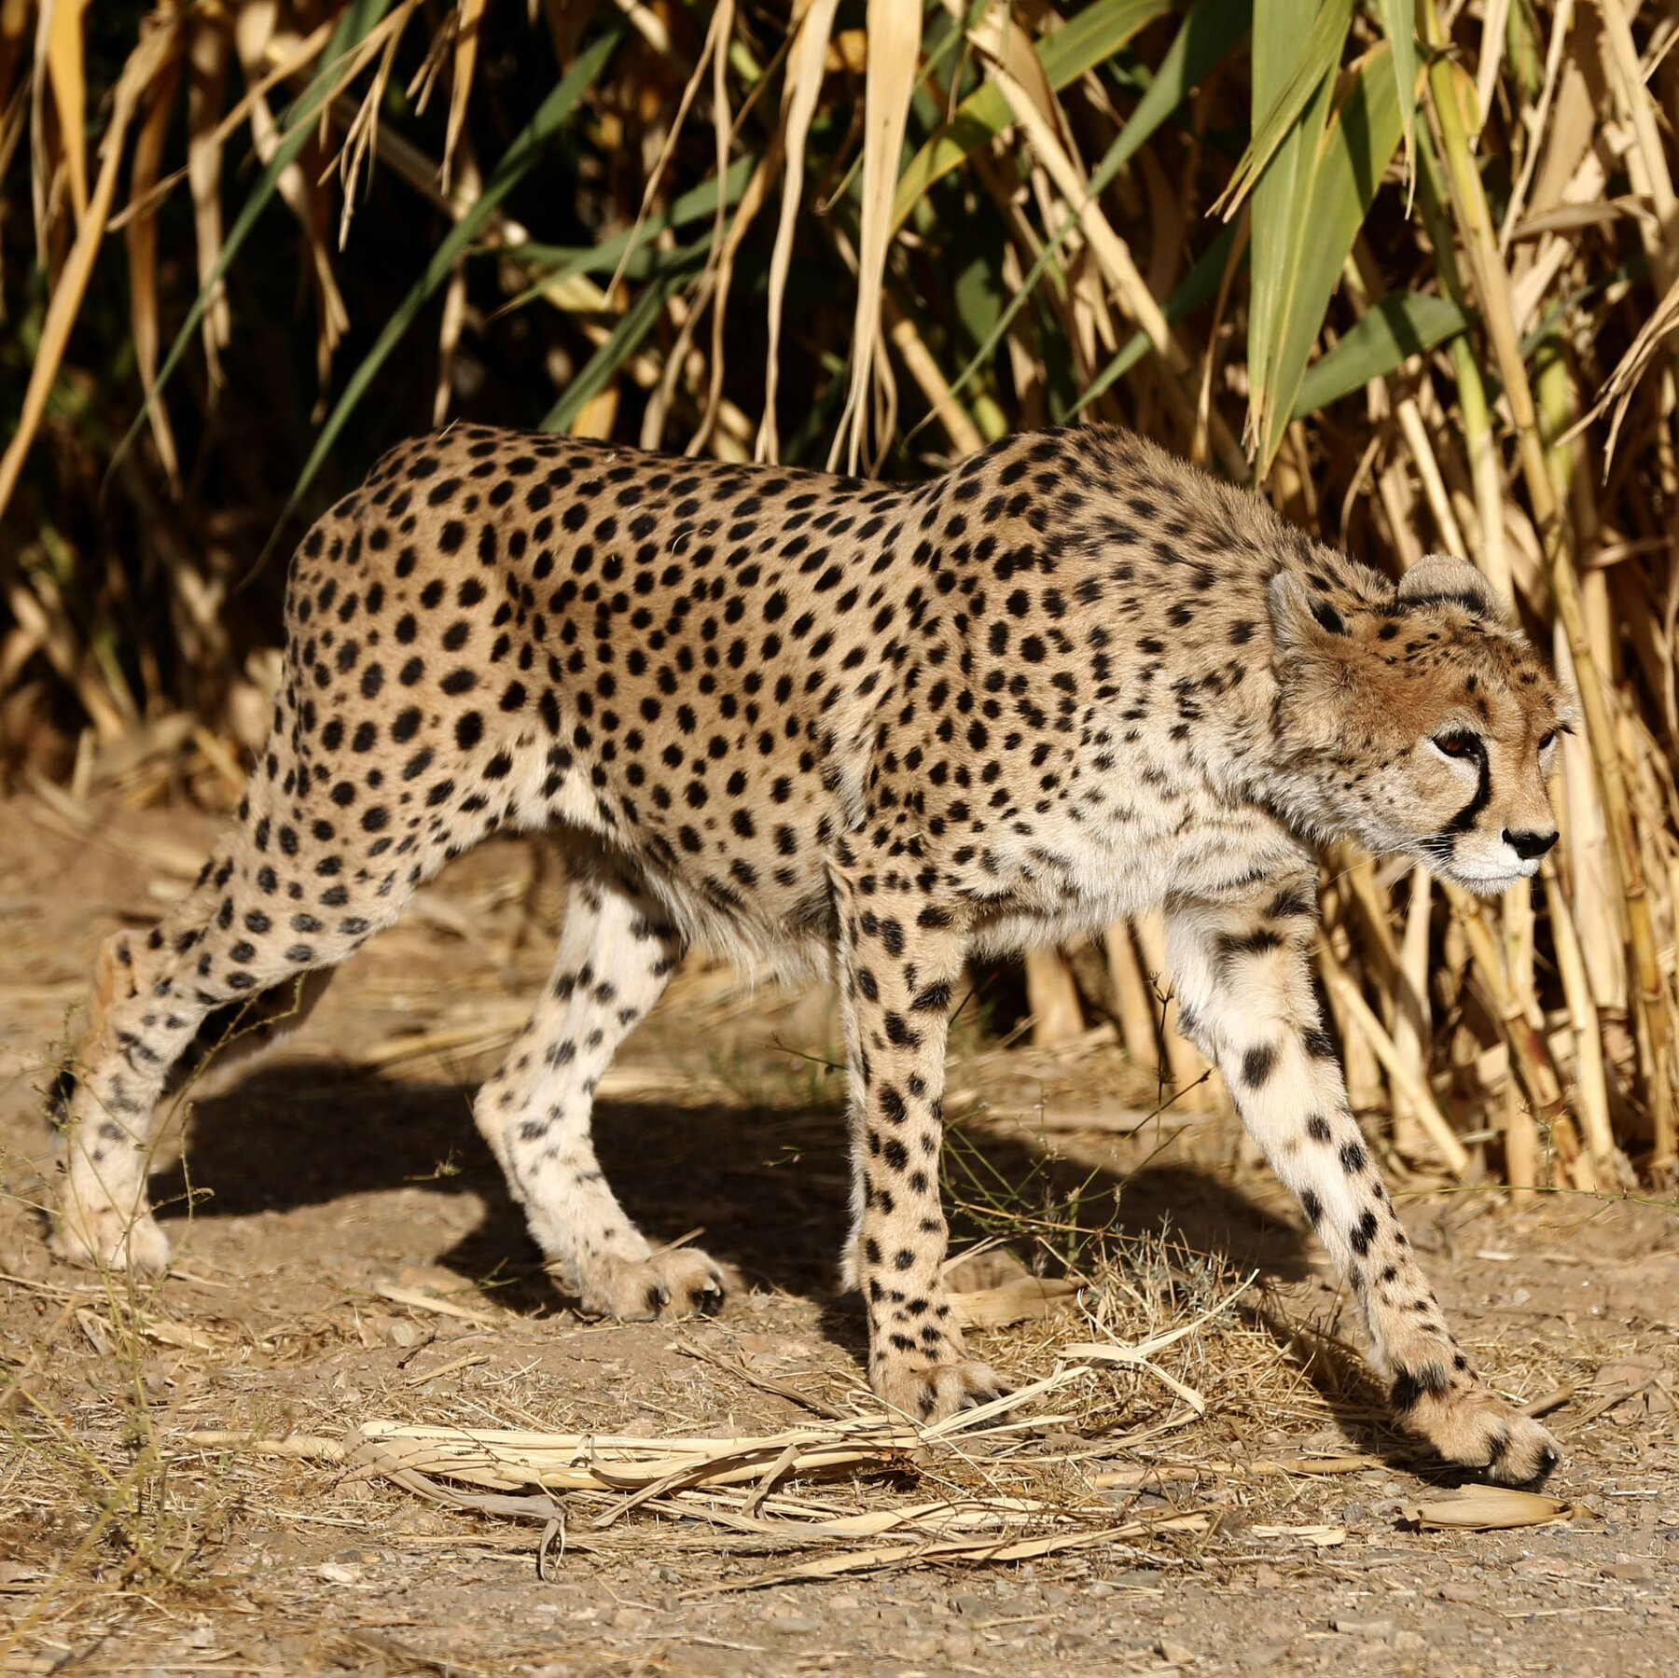
Conservationists say they have recorded several new adult and cub Asiatic cheetahs, a critically endangered subspecies found only in Iran. (Translated to Chinese)
原文链接：https://www.nytimes.com/2026/04/28/world/middleeast/iran-cheetah-sightings-war.html

Death toll after train crash near Indonesia’s Jakarta rises to 14 (Translated to Chinese)
来源: Al Jazeera 发布时间: 2026-04-28 01:22\n

The head of the national rescue agency says efforts continue to remove people trapped in wreckage. (Translated to Chinese)
原文链接：https://www.aljazeera.com/news/2026/4/28/five-killed-in-train-crash-near-indonesias-jakarta-rescue-efforts-ongoing?traffic_source=rss

