每日时事专刊

Australia news live: more than 100 people searching for missing girl near Alice Springs; protester charged over Palestine slogan pleads not guilty
来源: The Guardian - 发布时间: Wed, 29 Apr 2026 00:41:47 GMT
LLM处理要求：<p>Meanwhile King Charles praises ‘ambitious’ Aukus and expresses pride in Australia in speech to US...
关键点:
- LLM关键点待处理。
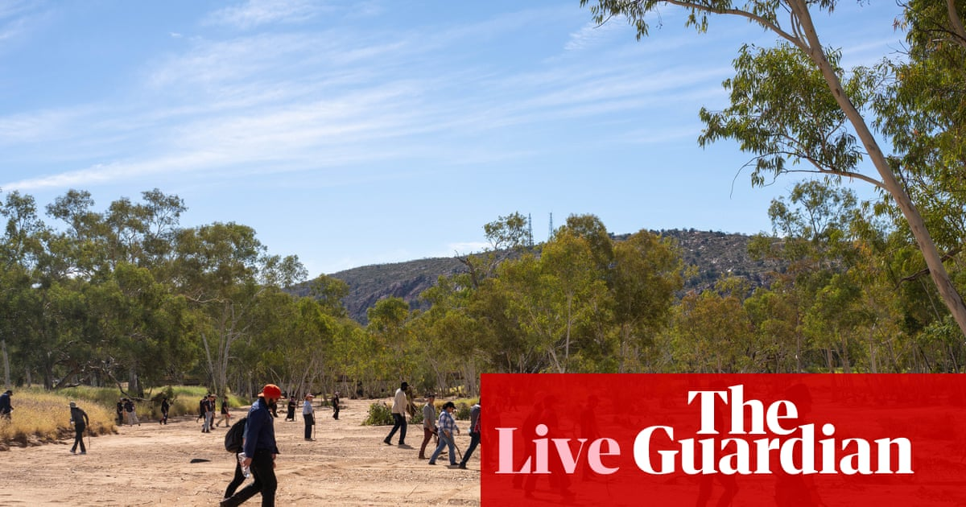
原文链接: https://www.theguardian.com/australia-news/live/2026/apr/29/australia-news-live-aukus-king-charles-one-nation-budget-cost-of-living-inflation-consumer-price-index-jim-chalmers-anthony-albanese-angus-taylor-ntwnfb

Comey charged with threatening Trump's life in Instagram post
来源: BBC World - 发布时间: Wed, 29 Apr 2026 00:24:05 GMT
LLM处理要求：The new case stems from a 2025 seashell photo posted by the former FBI director that the justice dep...
关键点:
- LLM关键点待处理。

原文链接: https://www.bbc.com/news/articles/cvgz4rvlem5o?at_medium=RSS&at_campaign=rss

Justice department claims Comey made ‘threat to kill’ Trump as it announces charges against former FBI director – live
来源: The Guardian - 发布时间: Wed, 29 Apr 2026 00:11:52 GMT
LLM处理要求：<p>Charges appear to stem from photo posted on Comey’s Instagram account last year; former FBI direc...
关键点:
- LLM关键点待处理。

原文链接: https://www.theguardian.com/us-news/live/2026/apr/28/donald-trump-king-charles-melania-camilla-white-house-congress-latest-news-updates

Iran war live: Trump says Tehran wants end to blockade; Israel kills medics
来源: Al Jazeera - 发布时间: Wed, 29 Apr 2026 00:00:00 +0000
LLM处理要求：US president says Iran has reached out and asked Washington to lift its naval blockade on Iranian po...
关键点:
- LLM关键点待处理。
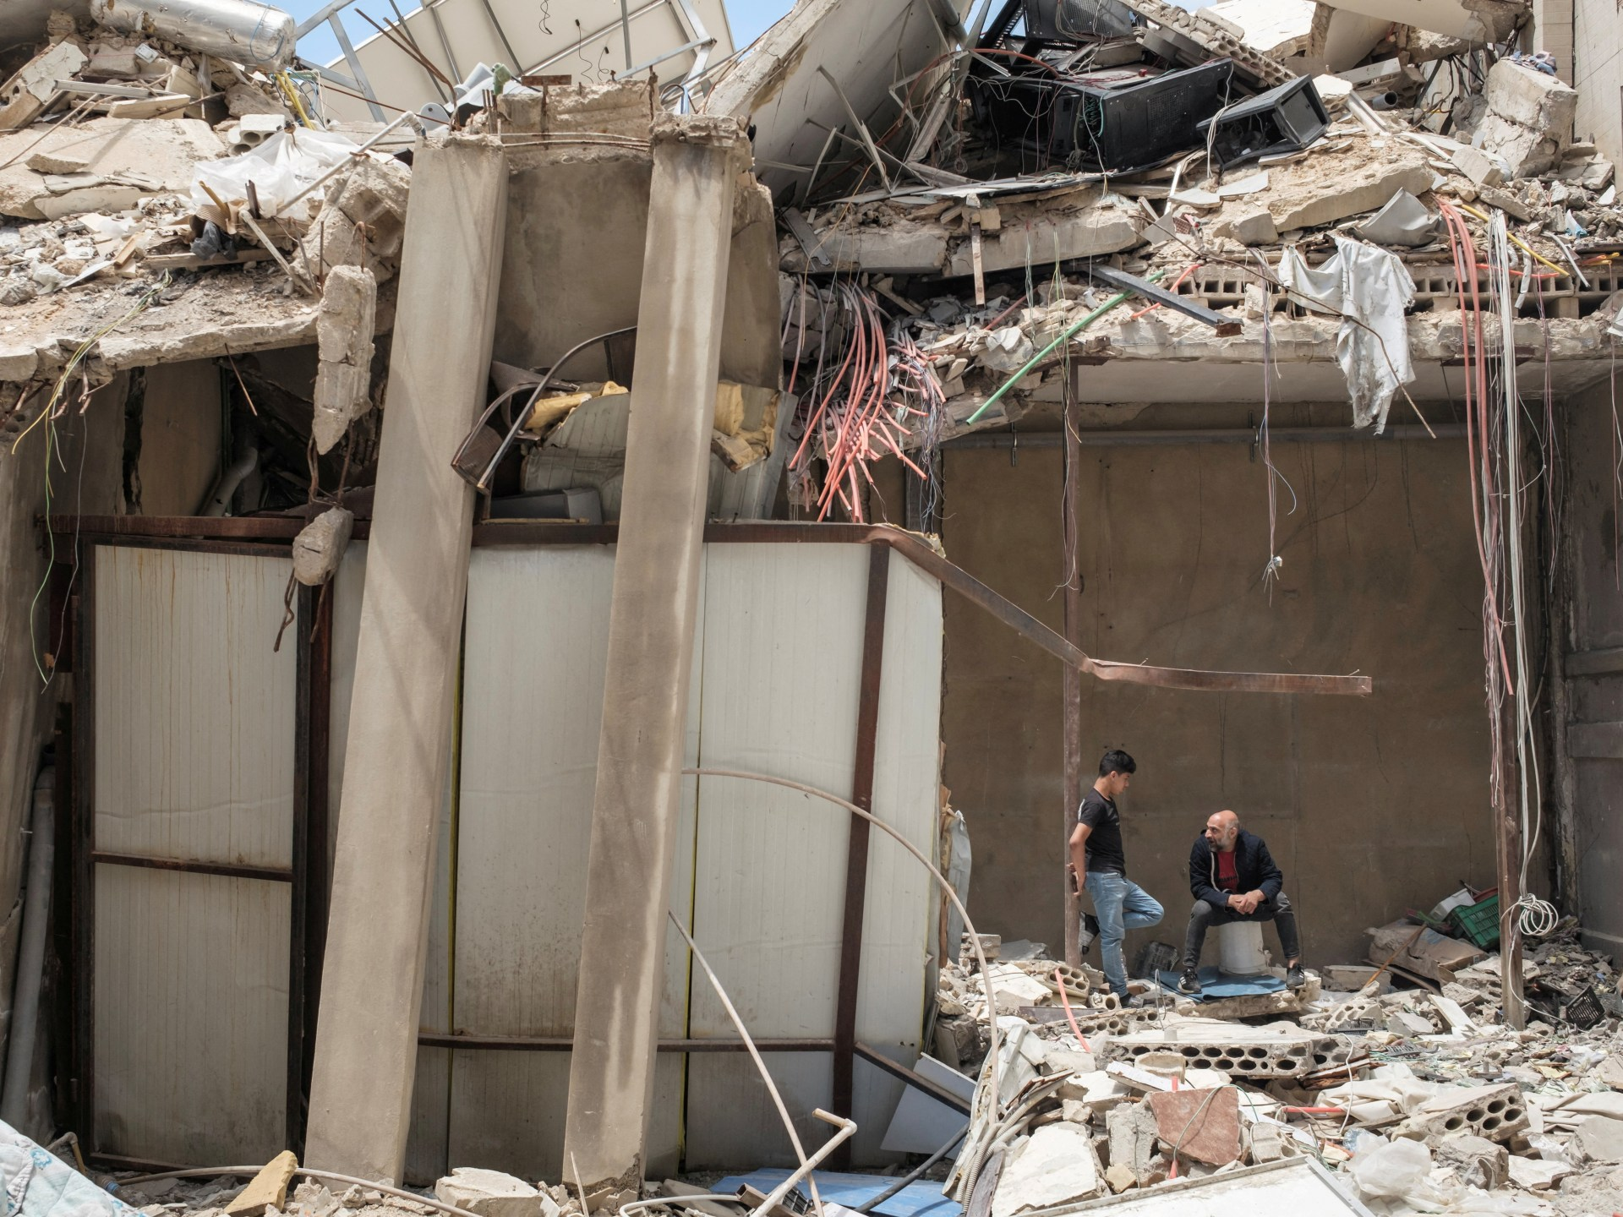
原文链接: https://www.aljazeera.com/news/liveblog/2026/4/29/iran-war-live-trump-says-tehran-wants-end-to-blockade-israel-kills-medics?traffic_source=rss

Teaching in classes grouped by ability does not hamper progress of less able pupils, study finds
来源: The Guardian - 发布时间: Tue, 28 Apr 2026 23:01:38 GMT
LLM处理要求：<p>Research on maths teaching in English secondary schools upends decades of debate over mixed-abili...
关键点:
- LLM关键点待处理。

原文链接: https://www.theguardian.com/education/2026/apr/29/teaching-classes-by-ability-does-not-hamper-less-able-pupils-study-secondary-schools-england

UK faces £35bn hit and risk of recession this year over impact of Iran war, thinktank warns
来源: The Guardian - 发布时间: Tue, 28 Apr 2026 23:01:38 GMT
LLM处理要求：<p>Niesr says even under best-case scenario, economy would grow at slower pace in 2026 and 2027 beca...
关键点:
- LLM关键点待处理。

原文链接: https://www.theguardian.com/business/2026/apr/29/uk-risk-of-recession-this-year-over-impact-of-iran-war-thinktank-warns

Israeli soldier shows Gaza’s Beit Hanoon completely flattened
来源: Al Jazeera - 发布时间: Tue, 28 Apr 2026 22:50:30 +0000
LLM处理要求：A video filmed by an Israeli soldier shows widespread destruction in northern Gaza....
关键点:
- LLM关键点待处理。

原文链接: https://www.aljazeera.com/video/newsfeed/2026/4/28/israeli-soldier-shows-gazas-beit-hanoon-completely-flattened?traffic_source=rss

Deaths projected to outnumber births in UK every year from 2026
来源: The Guardian - 发布时间: Tue, 28 Apr 2026 22:42:13 GMT
LLM处理要求：<p>Latest ONS figures also suggest lower population growth in coming decades than previously expecte...
关键点:
- LLM关键点待处理。

原文链接: https://www.theguardian.com/world/2026/apr/28/deaths-projected-to-outnumber-births-in-uk-every-year-from-2026

