每日时事专刊

News live: Syria claims Australian government ‘refused to receive’ families from detention camp trying to leave Damascus
来源: The Guardian - 发布时间: Wed, 29 Apr 2026 22:14:57 GMT
(翻译服务不可用，以下为英文原文总结) <p>Meanwhile Penny Wong says China has agreed to facilitate exports of jet fuel to ease supply disruptions. Follow today’s news live</p><ul><li><p>Get our <a href="https://www.theguardian.com/email-newsletters?CMP=cvau_sfl">breaking news email</a>, <a href="https://app.adjust.com/w4u7jx3">free app</a> or <a href="https://www.theguardian.com/australia-news/series/full-story?CMP=cvau_sfl">daily news podcast</a></p></li></ul><p><strong>Chalmers understands calls for gas export tax, but says government focused on getting fuel for Australians</strong></p><p>Chalmers said he understands calls to tax gas exports, but maintained the government was set on securing international supply arrangements during the ongoing fuel crisis. He told RN:</p><p>I understand that there is a constituency in the Australian community to go further … But there are also, as the prime minister said, really good reasons to prioritise these international supply arrangements particularly during this oil shock.</p><p>All of us have been prioritising getting fuel for Australia and for Australians to keep the economy ticking over and that’s why there are good for the comments that the prime minister made yesterday.</p><p>We’ve been very upfront with people and said when we think about the intergenerational unfairness in the budget, in our economy, in our society more broadly, a couple of the drivers of that are in housing, are in the tax system.</p> <a href="https://www.theguardian.com/australia-news/live/2026/apr/30/fuel-crisis-cost-of-living-penny-wong-royal-commission-antisemitism-virginia-bell-jim-chalmers-inflation-budget-anthony-albanese-angus-taylor-ntwnfb">Continue reading...</a>
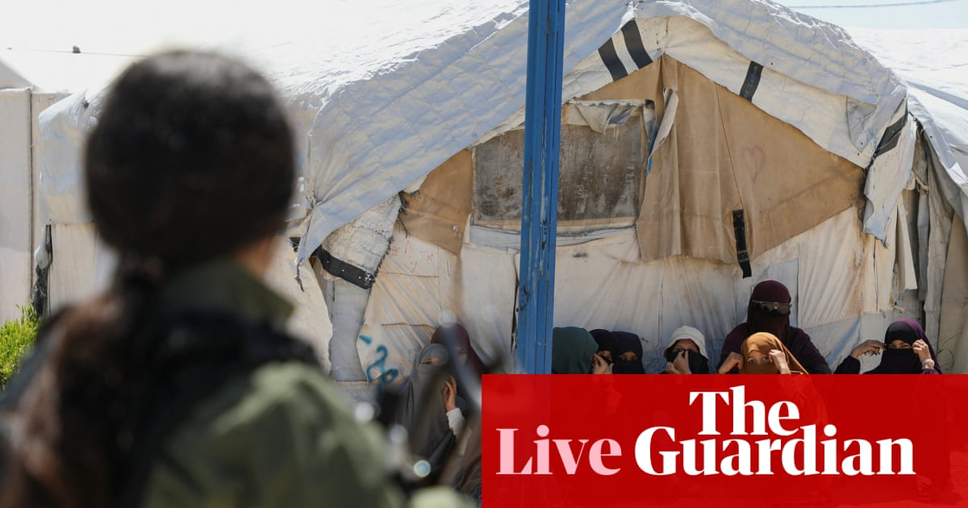
原文链接: https://www.theguardian.com/australia-news/live/2026/apr/30/fuel-crisis-cost-of-living-penny-wong-royal-commission-antisemitism-virginia-bell-jim-chalmers-inflation-budget-anthony-albanese-angus-taylor-ntwnfb

‘A day of loss for our democracy’: civil rights groups slam supreme court ruling that weakens key part of Voting Rights Act – live
来源: The Guardian - 发布时间: Wed, 29 Apr 2026 22:10:48 GMT
(翻译服务不可用，以下为英文原文总结) <p>NAACP, ACLU and Democratic politicians decry 6-3 supreme court decision as ‘a profound betrayal of the civil rights movement’</p><ul><li><p><a href="https://www.theguardian.com/news/2026/feb/17/sign-up-for-the-breaking-news-us-email-to-get-newsletter-alerts-direct-to-your-inbox?utm_medium=ACQUISITIONS_STANDFIRST&amp;utm_campaign=BN22326&amp;utm_content=signup&amp;utm_term=standfirst&amp;utm_source=GUARDIAN_WEB">Sign up for the Breaking News US email</a></p></li><li><p><a href="https://www.theguardian.com/us-news/2026/apr/29/supreme-court-louisiana-congressional-map-case-ruling">US supreme court ‘demolishes’ key Voting Rights Act provision that prevented racial discrimination</a></p></li></ul><p></p><p><strong>The US Federal Reserve is widely expected to hold interest rates steady on Wednesday after a key policy meeting, likely the last chaired by central bank chief Jerome Powell, a frequent target of president Donald Trump’s ire.</strong></p><p>Policymakers will weigh the risks of surging energy prices and snarled supply chains due to the US-Israel war on Iran, with analysts widely expecting a third pause in a row as the effects of the conflict ripple through the world’s largest economy.</p> <a href="https://www.theguardian.com/us-news/live/2026/apr/29/king-charles-new-york-donald-trump-zohran-mamdani-iran-us-politics-live">Continue reading...</a>

原文链接: https://www.theguardian.com/us-news/live/2026/apr/29/king-charles-new-york-donald-trump-zohran-mamdani-iran-us-politics-live

Israel has begun intercepting Gaza-bound Global Sumud Flotilla aid boats
来源: Al Jazeera - 发布时间: Wed, 29 Apr 2026 21:59:08 +0000
(翻译服务不可用，以下为英文原文总结) Organisers of a Gaza-bound aid mission say their vessels are being intercepted by Israeli military speedboats.

原文链接: https://www.aljazeera.com/video/newsfeed/2026/4/29/israel-has-begun-intercepting-gaza-bound-global-sumud-flotilla-aid-boats?traffic_source=rss

Israeli military speedboats block Gaza-bound aid ship
来源: Al Jazeera - 发布时间: Wed, 29 Apr 2026 21:46:23 +0000
(翻译服务不可用，以下为英文原文总结) This is a breaking news story.

原文链接: https://www.aljazeera.com/news/2026/4/29/israeli-military-speedboats-block-gaza-bound-aid-ship?traffic_source=rss

UAE quits OPEC
来源: Al Jazeera - 发布时间: Wed, 29 Apr 2026 21:30:22 +0000
(翻译服务不可用，以下为英文原文总结) The UAE announced it’s withdrawing from OPEC on May 1st.
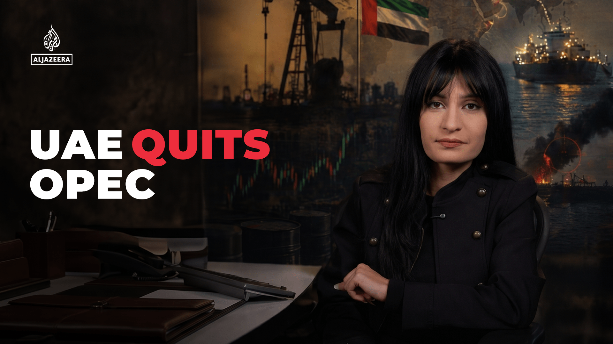
原文链接: https://www.aljazeera.com/video/newsfeed/2026/4/29/uae-quits-opec?traffic_source=rss

Stephen Fry sues tech conference organisers for £100,000 over fall from stage
来源: The Guardian - 发布时间: Wed, 29 Apr 2026 21:28:33 GMT
(翻译服务不可用，以下为英文原文总结) <p>Actor and presenter broke his hip, right leg, pelvis and ribs when he gave a talk at CogX festival at O2 Arena in 2023</p><p>Stephen Fry is suing two companies that organised a tech conference where he was injured in 2023 after falling off the stage, high court documents show.</p><p>The actor and presenter broke his hip and had multiple breaks in his right leg, pelvis and ribs when he attended the CogX festival at the O2 Arena, where he delivered a talk on artificial intelligence on 14 September 2023.</p> <a href="https://www.theguardian.com/culture/2026/apr/29/stephen-fry-sues-tech-conference-organisers-for-100000-over-fall-from-stage">Continue reading...</a>
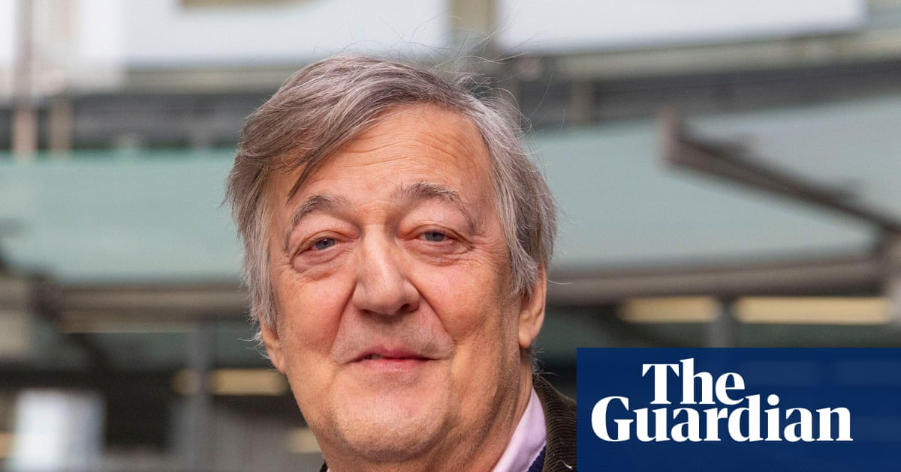
原文链接: https://www.theguardian.com/culture/2026/apr/29/stephen-fry-sues-tech-conference-organisers-for-100000-over-fall-from-stage

Golders Green attack claim highlights rise of shadowy Iran-linked group
来源: The Guardian - 发布时间: Wed, 29 Apr 2026 21:12:05 GMT
(翻译服务不可用，以下为英文原文总结) <p>HAYI has taken responsibility for a string of incidents targeting Jewish sites, but investigators say the latest claim may be opportunistic rather than state-backed</p><ul><li><p><a href="https://www.theguardian.com/uk-news/2026/apr/29/stabbing-golders-green-london">Police treating stabbing of two men in Golders Green as terrorism</a></p></li></ul><p>It took just over an hour after the horrific knife attack on two British Jewish people in Golders Green, north London, for an Iran-linked terror group, Harakat Ashab al-Yamin al-Islamia (HAYI), to make a claim of responsibility on a Telegram channel.</p><p>Counter-terror police are aware of the initial posting – a brief statement accompanied by the group’s logo – put online at 12.23pm and a follow-up 40 minutes later showing a violent attack at a bus stop.</p> <a href="https://www.theguardian.com/uk-news/2026/apr/29/golders-green-attack-claim-highlights-rise-of-shadowy-iran-linked-group">Continue reading...</a>

原文链接: https://www.theguardian.com/uk-news/2026/apr/29/golders-green-attack-claim-highlights-rise-of-shadowy-iran-linked-group

Arsenal cruelly denied penalty by VAR in Champions League draw at Atletico
来源: Al Jazeera - 发布时间: Wed, 29 Apr 2026 21:08:48 +0000
(翻译服务不可用，以下为英文原文总结) Arsenal scored one penalty, but VAR controversially denied them another in a 1-1 semifinal draw at Atletico Madrid.

原文链接: https://www.aljazeera.com/sports/2026/4/29/arsenal-cruelly-denied-penalty-by-var-in-champions-league-tie-at-atletico?traffic_source=rss

